Global Creative Art & Poetry Competition:

2022 Theme - A Whole New World
In March 2020 amid the coronavirus and blood shortages, the United Kingdom Thalassaemia Society (UKTS) started its’ first global art competition for children. Our main aims were to encourage children and adults to understand the importance of donating blood in their respective countries around the world and to raise awareness of thalassaemia. In 2020, UKTS received over 293 entries from 47 countries.
Following the positive message of the competition, it’s success and global unity, the board of trustees decided to make it an annual event. The competition had many fans and supporters and one of which was Silence Therapeutics (a pharmaceutical company who is currently conducting clinical trials in thalassaemia) offered to sponsor the event.
Following feedback from our global community in 2020, UKTS extended the competition to include adults of all ages to ensure inclusivity. There were 654 entries submitted from 55 countries. Due to the exceedingly high standards of entries submitted, the UKTS board added on an additional 13 prizes (called trustees awards) to the original 12.
This new year we are back with a bigger and improved version based on YOUR comments. Not only have we changed the theme and increased the number of prizes, we also have included another category (poetry) to the previous art competition. There are also 5 age groups! (3-5, 6-9, 10-12, 13-16 and 17+) and 30 prizes to be to be won in total- 15 in each category!
The competition is being sponsored by Silence Therapeutics for the third year!
This year’s theme is: A Whole New World!
Why did we choose this theme?
Coronavirus has been difficult for everyone, and we thought this year we should focus on the things that make our hearts and lives happier. What are some of the things you look forward to achieving, doing, designing, playing in this new year- do you have any new hobbies? Whether you draw or write about your aspirations of going to the moon or things you would like to eat or do- we are all in!
Let’s share some positivity this year and display what some of our dreams are!
Ps: if donating blood is one of those things or finding out about thalassaemia- we will accept this too!
Are you ready to create a masterpiece?
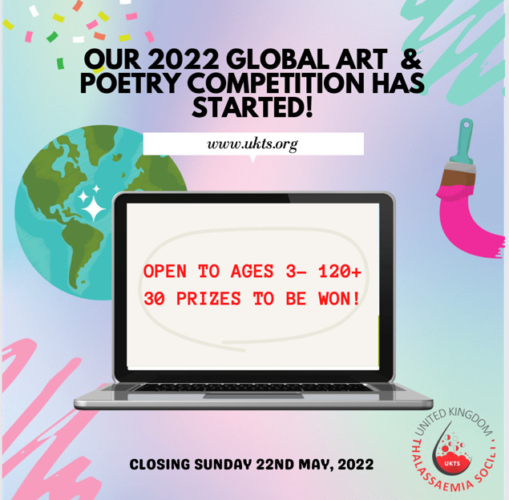

Competition- HASHTAGS-
#UKTScreative #teamukts #uktsartcomp
Who is eligible to enter?
The competition is open to all children and adults throughout the world. Parents/ Guardian consent will be needed for children under 16. You must agree to the terms and conditions to enter.
What do I need to submit?
1. Title of your piece
2. Upload your work
Your creative response on the theme of “A Whole New World”. This could be a painting, drawing, illustration, graphic art, comics, poetry or similar.
- Images/graphics must be in .jpg, gif or .png format only- Maximum file size: 5mb
- Poetry or creative writing must be in ms word or pdf format only
3. Reflective explanation of your submission – maximum 200 words outlining why you chose it and what it means to you personally and how it reflects the theme of “A Whole New World”- must be in ms word or pdf format only
4. Please note that you/your child can only submit your/their own work that has been created especially for this competition. This means that you cannot submit creative work that has been or will be used in any other competition.
Can I submit an entry in my preferred language?
Yes, however, please note you will also have to submit an English translation to accompany the piece of creative work.
Can I submit the reflection in my preferred language?
Yes, however, please note you will also have to submit an English translation to accompany the piece of creative work.
Can I submit a piece of writing or poem?
Yes. Please note that you will have to submit your own English translation to the promoter.
When does the competition begin?
The competition begins on Friday 24th February 2022.

When is the deadline for submission?
The competition will close on Sunday 22nd May 2022, at 11.59 BST.
When will the winners be announced?
The competition winners will be announced on Tuesday 14th June 2022 (world blood donor day) via our website and social media channels. Twitter and Instagram- @teamukts and Facebook (United Kingdom Thalassaemia Society)
Should you win, you will not be required to attend in person. You will be contacted by a member of our team who will help to ensure you receive your prize!
What are the terms and conditions of entry?
Please click here to read the full terms and conditions of entry or go to www.ukts.org to access the terms and conditions.

